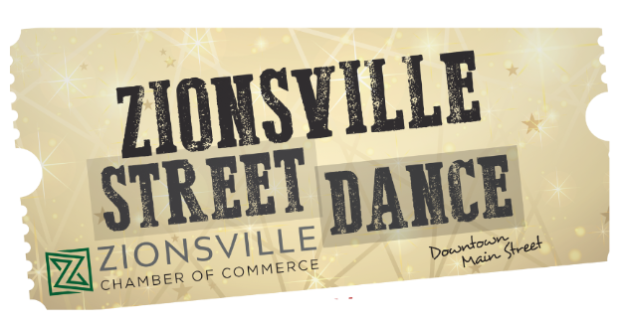
FAQ
- What is the Zionsville Street Dance?
  - The Zionsville Street Dance is an annual celebration concert held on the North end of Zionsville’s iconic Brick Main Street.
- When is the Zionsville Street Dance?
  - Saturday, September 26, 2026 – This is a make-up date from 8/1/2026
  - Gates open at 5:00 PM.
  - The Janeways perform from 6:30-7:30 PM
  - The Flying Toasters perform from 8:00-10:00 PM
- Street Dance Cost
  - Adult Tickets (Ages 11+):
    - Available online at www.zionsvillechamber.org for $20, or $25 at the gate (card or cash) on the day of the event.
  - Children (Ages 10 and Under):
    - Admission is $10.
  - VIP Tickets:
    - A limited number of VIP tickets are available for $75. This includes event admission and access to a reserved space at COhatch and Radiant Skin. Please note: food and drink are not included.
    - VIP tickets will be available until the Wednesday before the event or until sold out, whichever comes first.
- Food & Beverage:
  - A variety of visiting food and beverage vendors will be on site, accepting both card and cash.

- How do I purchase tickets?
  - Tickets can be purchased in advance at www.zionsvillechamber.org or at the gate the day of the event.
- Will I need cash or a credit card?
  - Both forms are accepted at the ticket entry gates and with the various vendors.
- Wristbands.
  - All attendees will receive a CCH+A wristband upon check-in (color dependent on age). Anyone without a wristband will be asked to leave by local authorities. ALCOHOLIC BEVERAGES CANNOT BE PURCHASED BY ANYONE UNDER 21.
- Are dogs allowed?
  - We encourage you to leave pets at home, especially since the noise and crowd can be overwhelming.
- Will there be food and beverages?
  - Yes, there will be several various food and beverage vendors for you to enjoy from pizza, chicken sandwiches, sliders, pies, ice cream and more. There will be beer vendors, wine vendors, a spirts vendor, and a mocktail vendor. In addition, area restaurants will remain open for you to patronize.
- Can I bring outside food, beverages or a cooler?
  - No alcoholic beverages are permitted to be brought in. We have a variety of food and beverage vendors and encourage you to support them. You can also bring your own food and non-alcoholic beverages.
- Where do I park?
  - You can park at Lions Park and along the side streets of Downtown Zionsville.
- Is there Handicap parking?
  - Yes. The Handicap parking area is located on W. Oak Street. You must enter from First Street.
- What happens if there is inclement weather?
  - Like most outdoor events, we’re at the mercy of mother nature. If inclement weather occurs, then local authorities will make the decision whether to continue the event. We encourage you to monitor the weather and bring appropriate weather attire.
- What happens if the event is canceled?
  - Your safety is our priority, and local authorities will decide whether to continue an event. If cancelled, there will be no refunds or rain-date.

